CO4-AT2 -CODING GOLF COMPETITION
NAME: S.MAHALAKSHMI
REG NO: 192524372
COURSE:DATA STRUCTURE
COURSE CODE: CSA0311

Q1: BUBBLE SORT
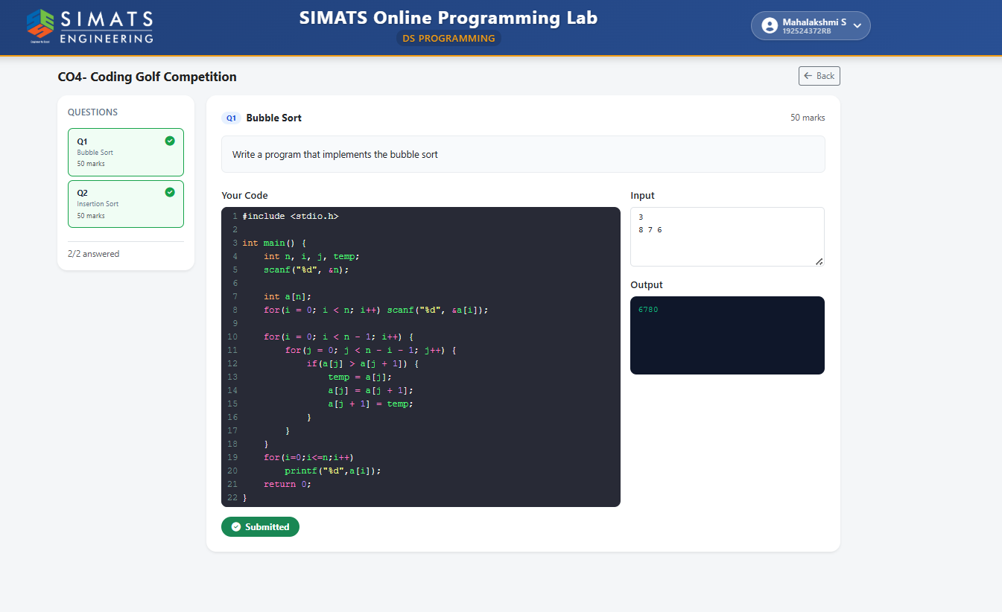

Screenshot 2 – INSERTION SORT
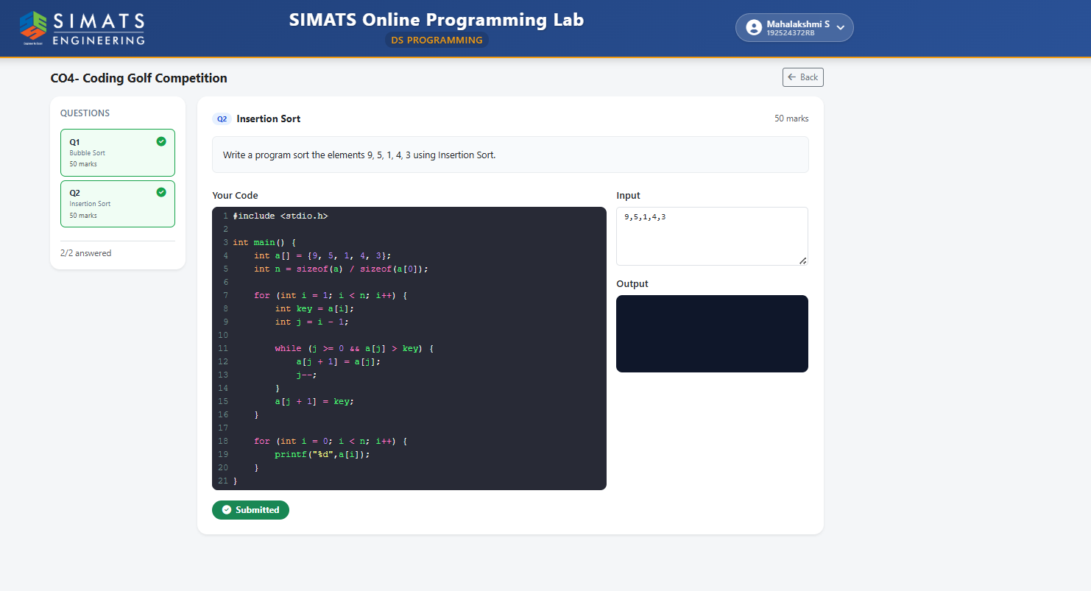

Screenshot 3 – All Questions Answered
